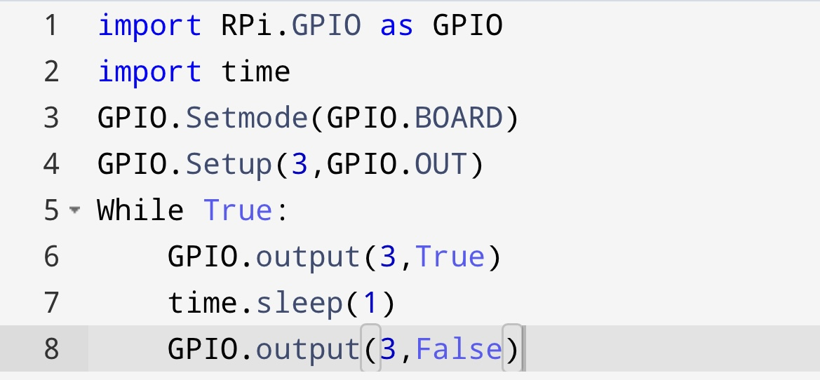PYTHON CODE FOR BLINKING LED AND TRAFFIC LIGHTS FOR RASBERRY PI

